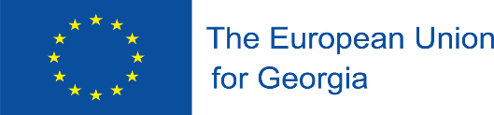


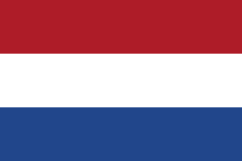


This project is funded by the European Union

“Strengthening Blood Safety System in Georgia”

Activity 2.1.1. Roundtable discussions on the establishment of the NCA as required by EU Blood Directives

13 July 2020

STEs:

Ms. Laimute Stoniene, Head of Quality Assurance Department, National Blood Center, Lithuania;
Ms. Agne Kaminskiene, Lawyer, National Blood Center, Lithuania;
Mr. W.Martin Smid, Managing Director of Sanquin Consulting Service, Sanquin Blood Supply Foundation, Netherlands;
Mr. Wim de Kort, Professor of Donor Health Care, University of Amsterdam, Netherlands;
Ms. Olenka van Ardenne, Senior Legal Counsel, Sanquin Blood Supply Foundation, Netherlands.

Monday, 13 July, 2020

14:00 – 14:10 | Adjustment of technical issues (voice, image)
14:10 – 14:15 | Opening speech – Mr. Amiran Gamkrelidze, NCDC General Director, BC Project Leader
14:15 – 14:30 | Overview of the current legal acts related to the control of blood establishments in Georgia – Mr. Anzor Chavchavadze (MoIDPLHSA)
14:30 – 14:45 | Discussion of the options of establishing NCA and its functions in Georgia - Ms. Babilina Turkia (RTA-C)
14:45 - 15:00 | Overview of the licensing requirements for blood establishments in Lithuania – Ms. Laimute Stoniene, Ms. Agne Kaminskiene
15:00 - 15:30 | Discussion of functions of NCA in Georgia : NCA responsibility for hemovigilance issues - All STEs
15:30 – 16:00 | Questions - Answers
 | End of the Teleconference

